**DESIGN DOCUMENT**

**Introduction**

The purpose of this design document is to provide information that is used in the development of the HELPFit system. The design document shows the description of the system about what and how different components are designed and built to satisfy the functional and non-functional requirements of this system.

**Architectural Design**

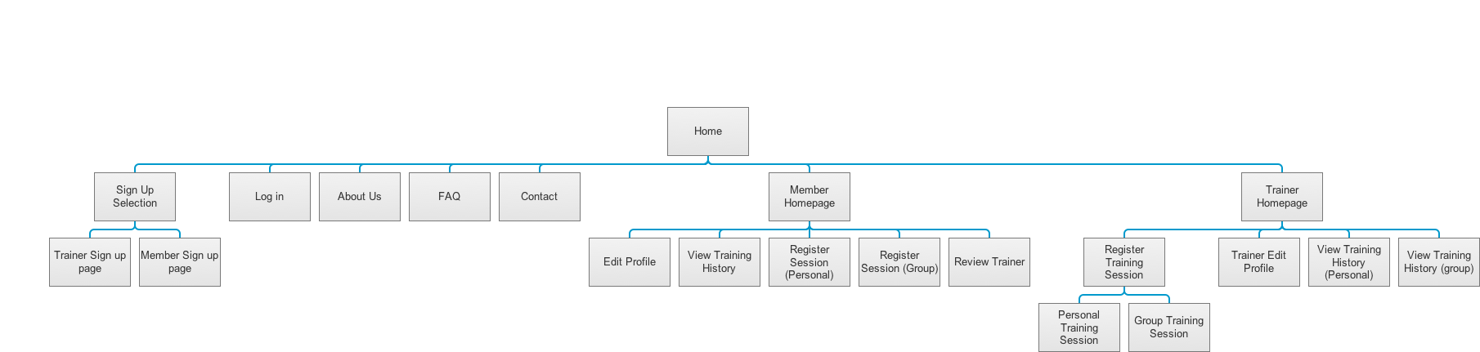

**System Design**

Design Class Diagram

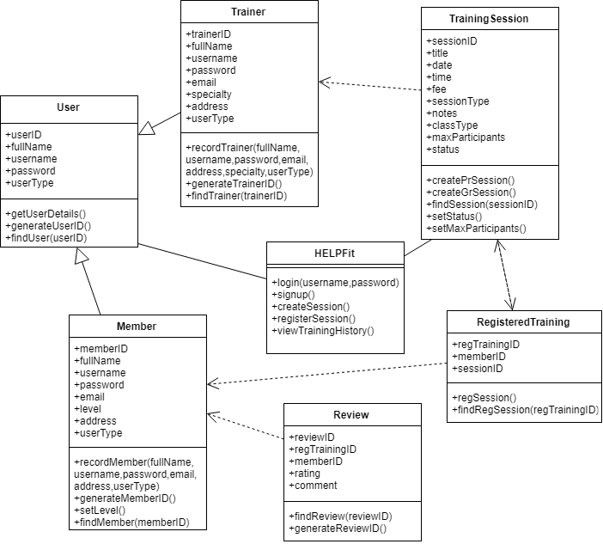

Sequence Diagrams

Use Case 1 : Sign Up

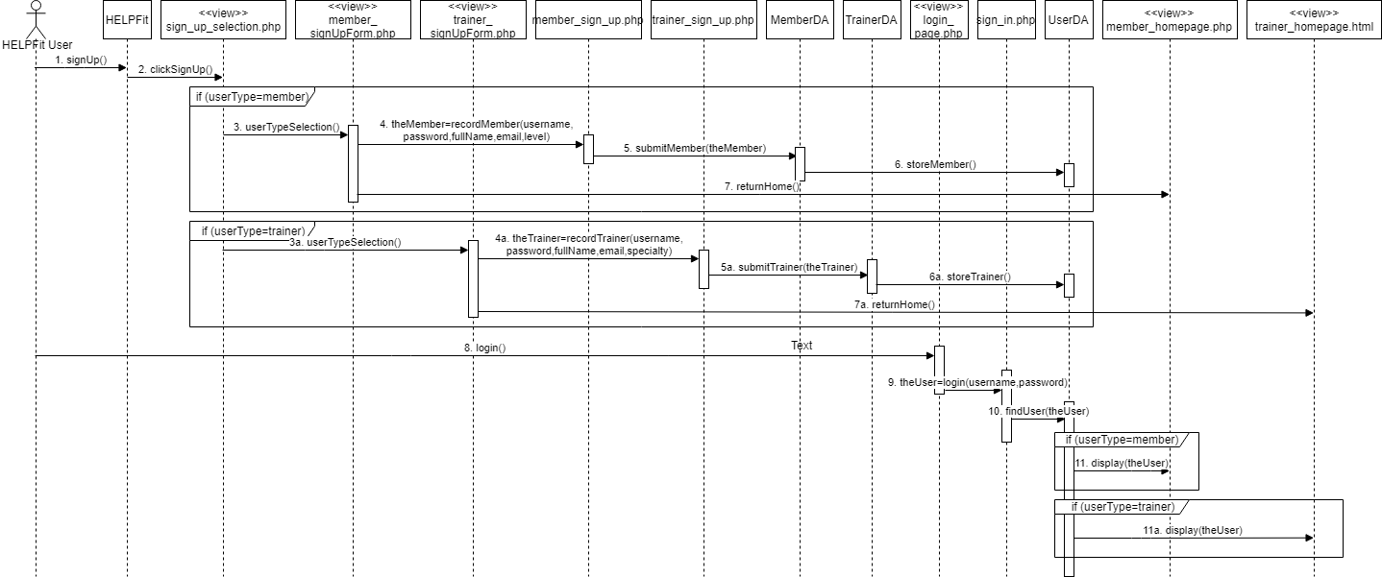

Use Case 2: Record Training Session

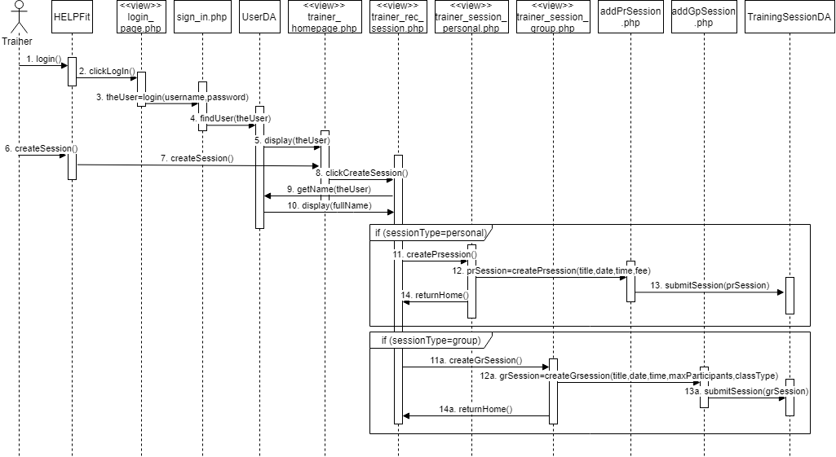

Use Case 3: Register for Training Session

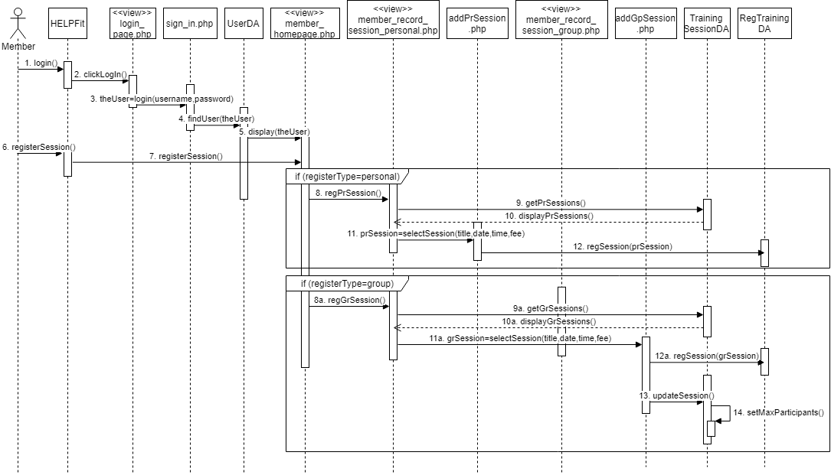

Use Case 4: View Training History

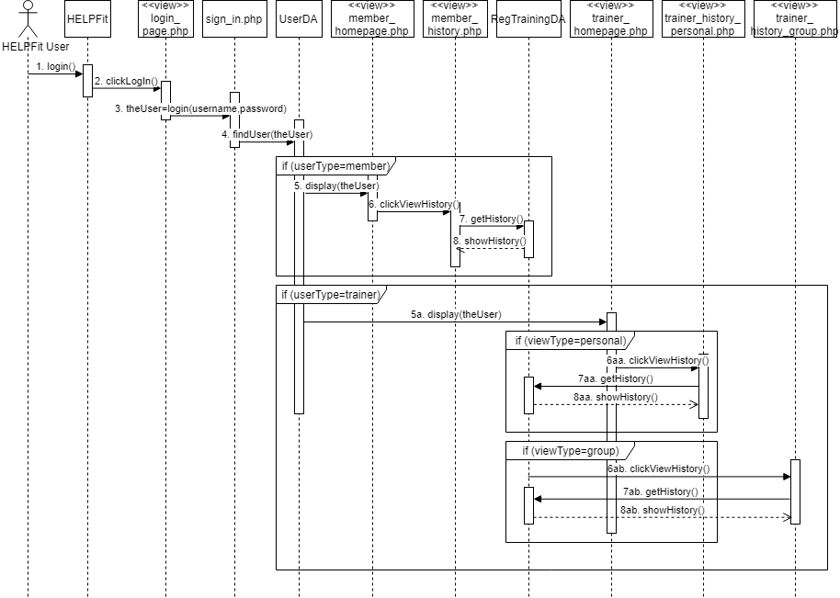

**Database Design**

Entity Relationship Diagram

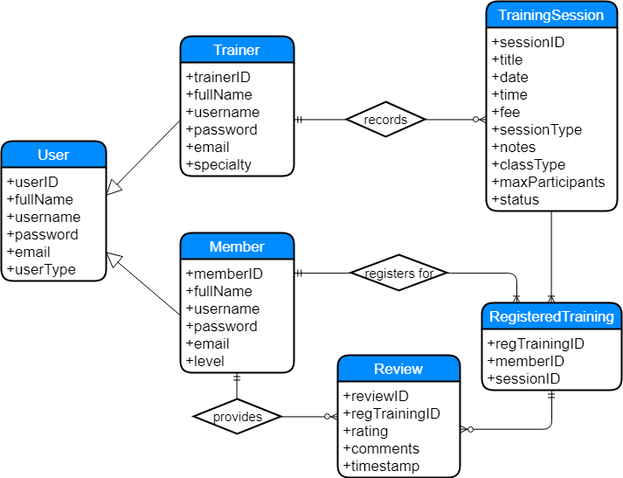

**Wireframes**

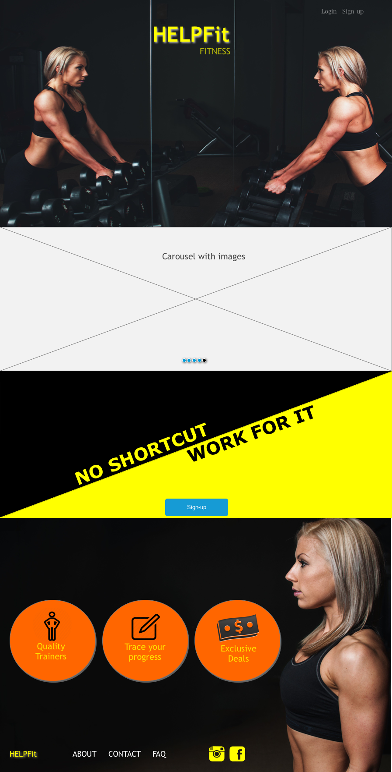

homepage.php

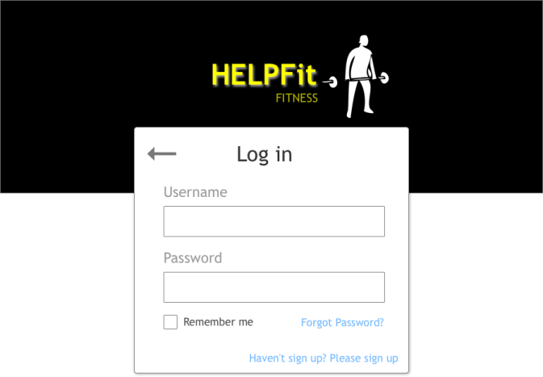 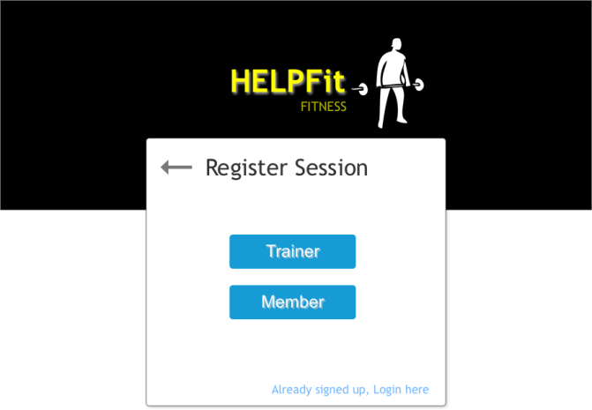

login_page.php sign_up_selection.php

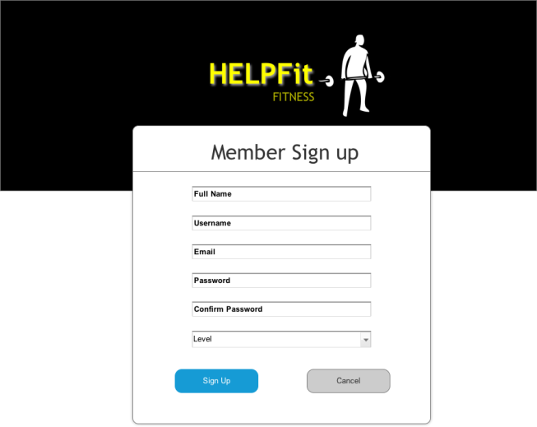 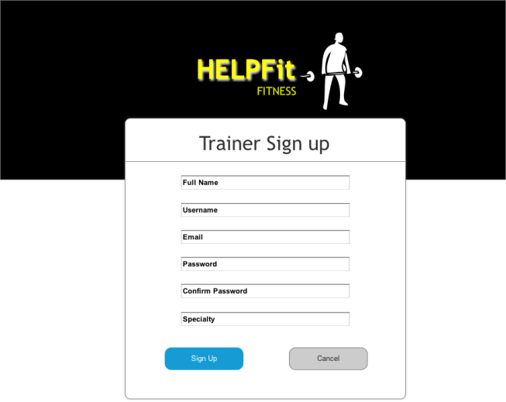

member_sign_up.php trainer_sign_up.php

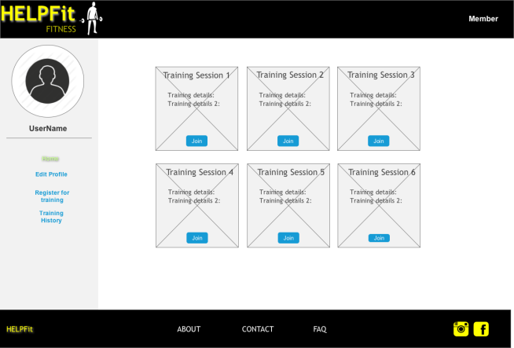 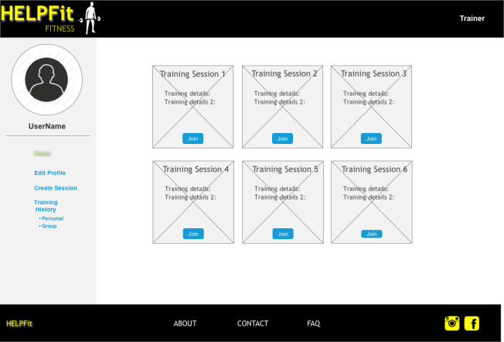

member_homepage.php trainer_homepage.php

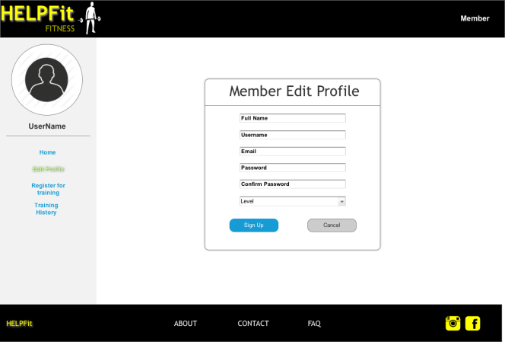 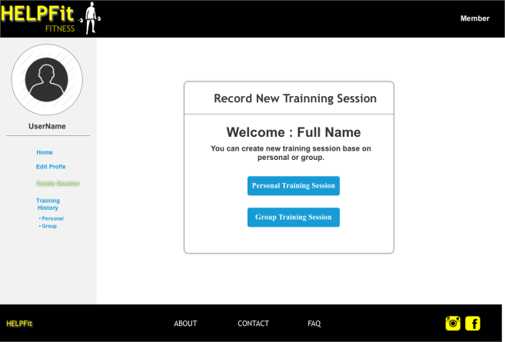

member_edit_profile.php trainer_rec_session.php

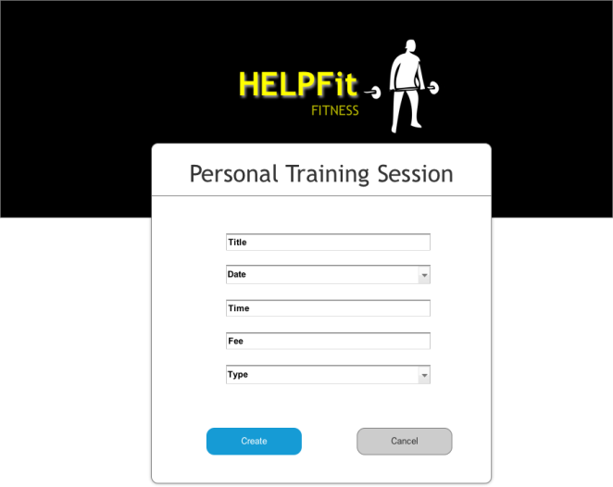 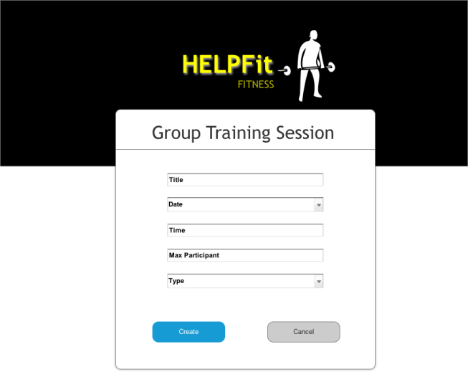

trainer_session_personal.php trainer_session_group.php

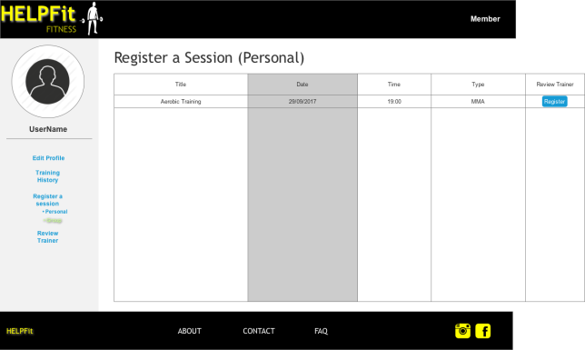 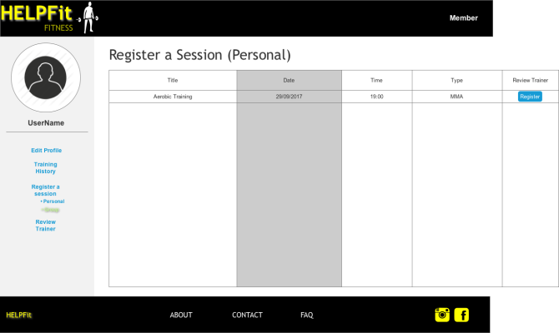

member_register_session_personal.php member_register_session_group.php

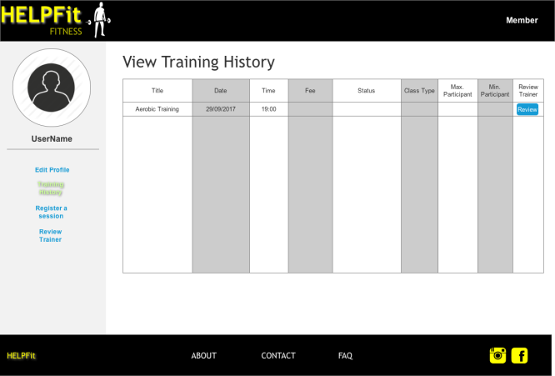 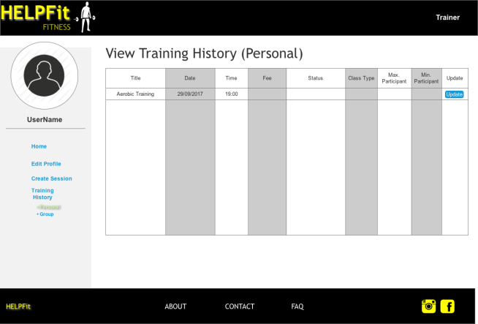

member_history.php trainer_history_personal.php

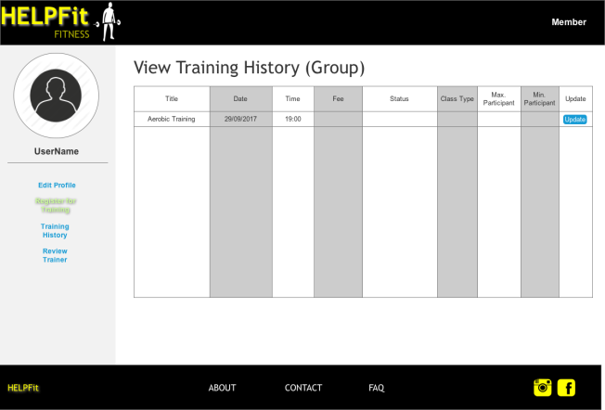 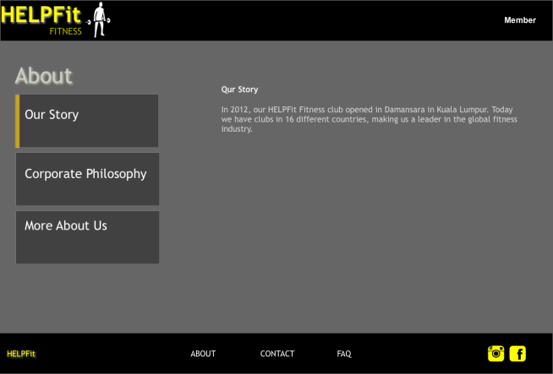

trainer_history_group.php about.php

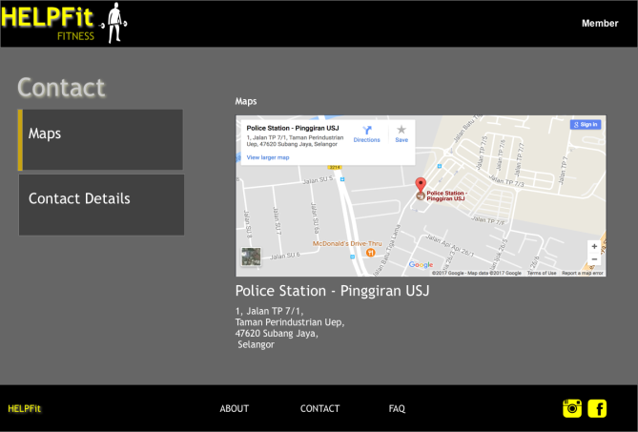 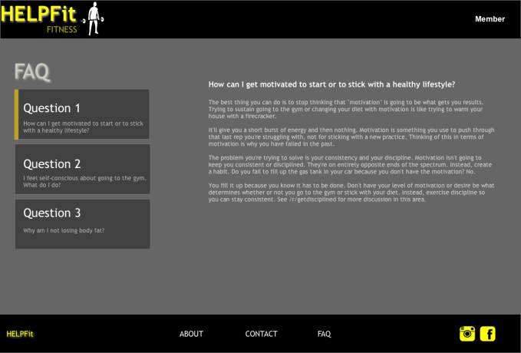

contact.php faqpage.php